**R Code for Examples in the book**

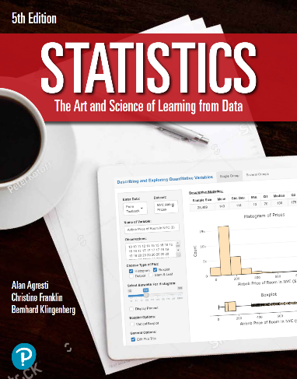

***“Statistics: The Art and Science of Learning from Data”***

**by Agresti, Franklin and Klingenberg, 5th edition**

**Chapter 6**

**Example 12: Speed Dating – Binomial Probabilities**

## To find the probability of 2 matches with 3 candidates with a probability of 0.2 for a match

dbinom(2, size = 3, prob = 0.2)

## [1] 0.096